Facts and Figures

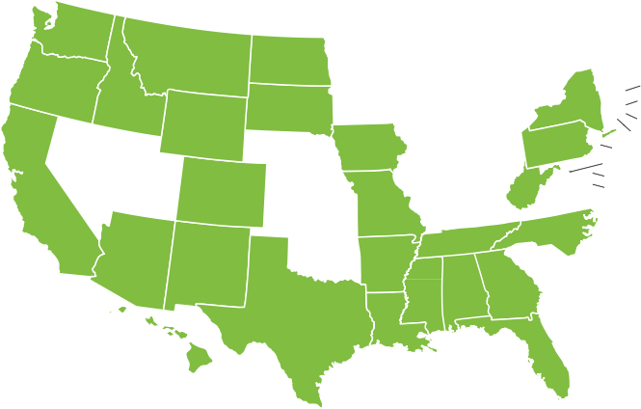
All 50 states and the District of Columbia have recognized that regulation of landscape architecture is necessary to protect the public health, safety, and welfare.
WA
ME
MT ND
OR
MN
VT
ID
SD
WI
NY
WY
MI
NH MA
RI CT
CA
NV
IA
PA
NE
OH
UT
IL IN
CO
WV
NJ
DC DE MD
KS
MO
KY VA
NC
AZ
NM
OK
TN
AR
SC
MS AL
GA
AK
TX
LA
HI
FL
Landscape architecture licensure is important because of the real danger to clients and the users of these public and private spaces: physical injury; property damage; and financial ruin.
States typically follow the three-step process to earn licensure common among the design professions: education, experience, and examination.

Education

Most landscape architects have an accredited degree in landscape architecture. The Landscape Architectural Accreditation Board (LAAB) accredits bachelor- and master-level programs at 68 institutions across the United States.

Experience

Most states require that landscape architects have 2–4 years experience under a licensed landscape architect in that state. Many states provide some flexibility for educational background, allowing candidates with more years of experience to qualify without an accredited degree, reducing barriers to entry into the profession.

Examination

All states require every candidate to pass the four-part Landscape Architect Registration Examination (LARE). While education and experience standards ensure each candidate has been prepared to enter the profession, the LARE provides a definitive measure of competence to ensure each landscape architect will protect the public health, safety, and welfare.
Skills tested include: project development; site suitability; stormwater management; erosion control; hydrology; and irrigation. Candidates also must demonstrate competence in such areas as: layout of playground equipment; vehicular and pedestrian circulation; roadway alignment design; site lighting
layouts; manipulation of contours and spot elevations; calculations of slopes, grades, and volumes of material; design of surface and subsurface storm drainage, including hydraulic characteristics and storm drain connections; and site planning for buildings.

LICENSURE

Support Licensure

We urge your support of legislation that provides effective regulation of the practice of landscape architecture. Licensure ensures that only capable, trained professionals are performing landscape architecture work that impacts the public health, safety, and welfare.

asla.org/advocacy

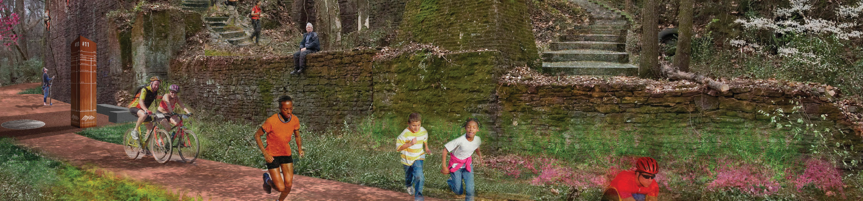
asla.org/advocacy

What Landscape Architects Do
Landscape architects plan livable communities that foster active lifestyles, design green streets that manage stormwater runoff, plan cutting-edge transportation corridors that are safe for all users, and help communities prepare for and recover from natural
disasters. Landscape architecture encompasses the analysis, planning, design, management, and stewardship of the natural and built environment through science and design. Well-known examples include Central Park in New York City, the grounds of the U.S. Capitol in Washington, D.C., the Oklahoma City National Memorial, and Chicago’s Millennium Park. Landscape architecture includes both iconic and neighborhood places, including commercial developments, downtown streetscapes, green roofs, local parks, and residential communities.

Licensure Protects Your Community
Fundamentally, the practice of landscape architecture should keep the public safe from hazards, protect and maximize natural resources, and prevent damage to public or private property from changes in the built environment. Landscape architects should provide stormwater solutions that effectively manage water to minimize runoff, improve water quality, control erosion, and eliminate safety hazards
from standing water/ice. Landscape architects should design a site—whether a playground, streetscape, campus, or park—that safely coordinates all uses of a site to avoid injuries and reduces the threat of crime. Landscape architecture should ensure roads, parking lots, medians and other transportation elements safeguard driver and pedestrian safety, are ADA accessible, and also provide environmental and community benefits.
The only way to make sure that landscape architects protect the public in these ways is to license landscape architects. The education, experience, and examination required to earn licensure provides a guarantee that the individual has demonstrated competency in all of the areas that impact the public health, safety, and welfare.

Licensure Protects Clients and Fosters Competition
States and localities recognize the dangers to the public from the built environment. This is evident not only through licensing, but through building codes and ordinances related to water, landscape, and other aspects that can pose a threat to the health and safety of our communities. These codes typically demonstrate the public trust of these communities in licensed professionals, requiring a licensee to oversee and stamp public and private projects that require public approval.
Excluding landscape architects from this system only serves to limit expertise and stifle competition for this industry. In the end, less competition means higher fees for these services. Errors and omissions insurance typically requires a license to qualify for coverage, making sure licensees are adequately able to take responsibility for any legal liability.

Image Credits
Page 1: 2017 General Design Honor Award. Chicago Botanic Garden: The Regenstein Learning Campus. Mikyoung Kim Design and Jacobs/Ryan Associates. (Image credit: Brian Fritz Photography) Page 2: 2012 Analysis and Planning Honor Award. Red Mountain / Green Ribbon — The Master Plan for Red Mountain Park. WRT, Philadelphia. (Image credit: Wallace Roberts & Todd, LLC)

