February 6, 2009

Ms. Carolyn Mitchell
Honors & Awards Coordinator
American Society of Landscape Architecture
636 Eye Street, NW
Washington, DC 20001-3736

LETTER OF ENDORSEMENT: Richard Shaw, FASLA, ASLA Design Medal

Dear Ms. Mitchell and the Selection Committee Members:

On behalf of ASLA Colorado Chapter, I take great pleasure in providing this endorsement of Richard Shaw, FASLA, for the 2009 ASLA Medal. The selection of a firm as the ALSA Firm of the Year requires the ultimate strength in design, quality of built work and personal relationships – and I believe that this honor could not have been bestowed upon Design Workshop without Richard’s leadership over the past 32 years.

The variety of work in Richard’s portfolio illustrates the breadth of his landscape architecture practice. Ranging from preservation to redevelopment and resort design to residential design, Richard has excelled in a broad range of project types in an industry in which many practitioners focus on a more specific niche. The ability to show consistent excellence across this range of work is an amazing accomplishment in its own right.

Along with his successful career, Richard has also been an active torchbearer of the profession. His involvement with ASLA (both with National and the Colorado Chapter), Landscape Architecture Foundation, Advisory/Alumni Councils at Utah State and the Harvard Graduate School of Design, and the Aspen Institute (among other organizations) illustrates his on-going dedication to the profession. As a chapter executive, I appreciate the influence of people who not only give their time to volunteer for an organization, but do so with the leadership, experience and patience.

Richard’s many years of dedication to his firm, design, promotion of landscape architecture, and the excellence in the enhancement of public and private spaces to enjoy, remember, and re-visit makes him an excellent candidate for this honor. Therefore, it is my honor to endorse Richard Shaw for the 2009 ALSA Medal.

Most Sincerely,
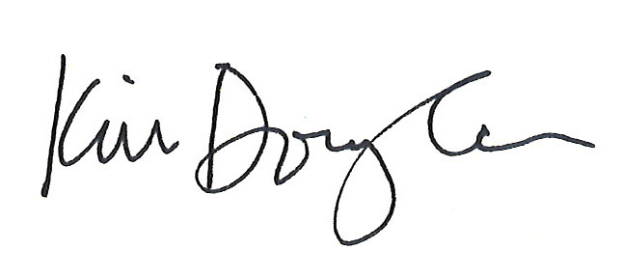
Kimberly R. Douglas
ASLA Colorado, 2009 Chapter President

