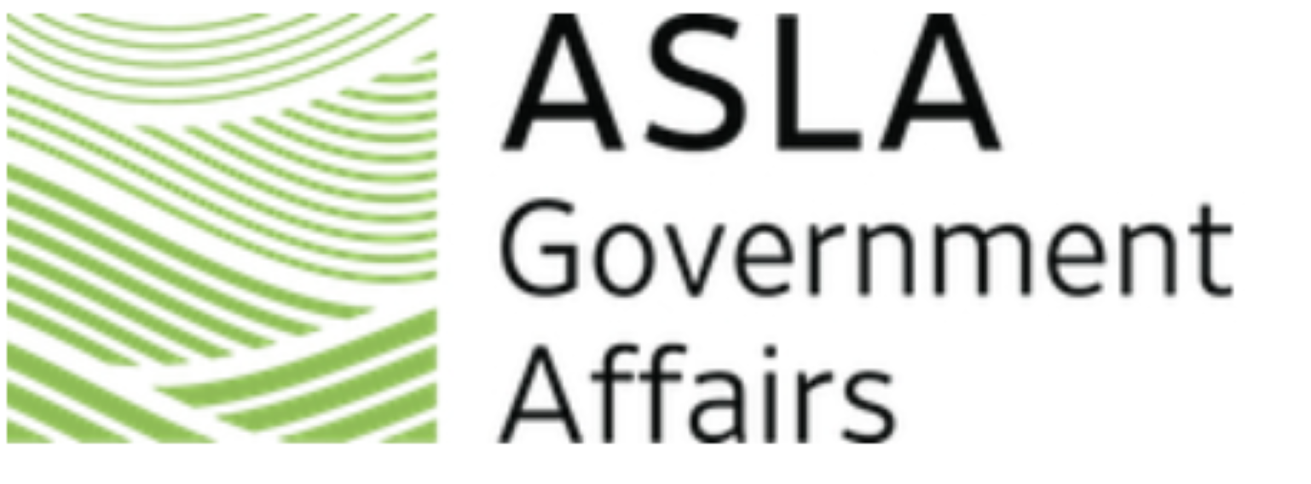
ASLA 2027 Virtual Advocacy Day
State Leads (updated 7/16)
Alaska  State Lead: Peter Briggs  Steven Callaghan  Alabama  State Lead: Kimberly Unruh  Paige Ishmael  Christina Argo  Arizona  State Lead: Amy Peron  Brandon Sobiech  California  State Lead: Andrew Wickham  Julie An  Patricia Ferman  Linda Hsi  Evan Mather  Colorado  State Lead: Sarah Konradi  Gregory Leichty  Charles Oropallo  District of Columbia  State Lead: Lesley Conroy  Linda Komes  Benjamin Jensen  Florida  State Lead: Kevin White  Samantha Fajardo  Georgia  State Lead: Jay Gehler  Sara Boyer  Iowa  State Lead: Lara Guldenpfennig  Madison Dierks  Garret Munch  Idaho  State Lead: Matthew Adams  Illinois  State Lead: Douglas Fair  Johann Friedl  Dave Lawrie  Zachary Rees  Amy Roberts  Sarah White  Indiana  State Lead: Kristopher May  Danica Liongson  Kentucky  State Lead: Thomas McKinley  Amin Omidy  Massachusetts  State Lead: Michael Radner  Michael Easler  Emily Scarfe  Maryland  State Lead: Patrick Whealton  Michael Humes  Amy Sommer  Julie Soss  Carla Ellern  JoAnn Trach Tongson  Michigan  State Lead: Robert Doyle  Stephanie Onwenu  Minza Shahid  Minnesota  State Lead: Kathleen Anglo  Lydia Major  Missouri  State Lead: J. Lee Feaster  Susan Maag  Jerany Jackson  Maria Landoni  Montana  State Lead: Zachary Heffernan  North Carolina  State Lead: Troy Olson  Paul Kuhn  Wendy Miller | North Dakota  State Lead: Gordon Lemmel  Nebraska  State Lead: Dennis Bryers  Kenneth Brandl  Samantha Howland  New Hampshire  State Lead: Christopher Clinton  New Jersey  State Lead: Alexis Bailey  Jan Saltiel-Rafel  Nevada  State Lead: Barbara Santner  Melinda Gustin  Kelly Miller  New York  State Lead: Kimberly Tryba  Michael DiCarlo  Slavica Mickovic  Vincent Ryan  Ohio  State Lead: Doug Boyer  Jeremy Hinte  Eugenia Martin  Kymberly Ware  David Wilson  Oklahoma  State Lead: Jeremy Crites  Oregon  State Lead: Mary Stewart  Pennsylvania  State Lead: Richard Rauso  David Bender  Rhode Island  State Lead: Elena Pascarella  South Carolina  State Lead: Holley Owings  South Dakota  State Lead: Brady Aldrich  Tennessee  State Lead: Caroline Lezon  Texas 1 – Senator Cruz  State Lead: Jonathan Wagner  Bobby Eichholz  Sarah Fitzgerald  Marissa McKinney  Margarita Padilla-Posey  Landon Bell  Texas 2 – Senator Cornyn  State Lead: Jacoby Gonzales  Diane Allen  Jessica Bacorn  Christopher Davis  Kaylin Slaughter  Matthew Stubbs  Jonathan Williams  Utah  State Lead: Thomas Eddington  Ernest Larum  William Ward  Virginia  State Lead: Terry Clements  Jacob Fox  David Lisowski  Christopher Lofstrom  Vermont  State Lead: James Palmer  Washington  State Lead: Curtis LaPierre  Wisconsin  State Lead: Sarah McDonald  Paige Bernhardt  Stephanie Wilson  West Virginia  State Lead: Jacob Burns

