Landscape architecture encompasses the analysis, planning, design, management, and stewardship of the natural and built environment through science and design. Well-known examples of landscape architecture include Central Park in
New York City; the grounds of the U.S. Capitol in Washington, D.C.; the Oklahoma City National Memorial; and Chicago’s Millennium Park. Landscape architecture includes both iconic and neighborhood places, including local parks, residential communities, commercial developments, and downtown streetscapes.

The fundamental practice of landscape architecture includes keeping the public safe from hazards, protecting natural resources, and sustainably managing the natural and built environment surrounding our homes and communities. The public interest is best served when qualified professionals carry out these responsibilities.
Landscape architects create well-planned livable communities, leading the way in initiatives such as neighborhood master plans, designing green streets, managing stormwater runoff, and planning cutting-edge transportation corridors.

What Landscape Architects Do
Landscape architecture is a profession that is broad in scale and scope. Landscape architects receive education and training in site design, historic preservation, and planning, as well as
in technical and scientific areas such as grading, drainage, horticulture, and environmental sciences. With this diverse background, landscape architects possess a unique blend of skills to help families, communities, and businesses address important local, regional, and national concerns.
Landscape architecture is regulated by state licensure requirements. Becoming licensed generally requires a university degree in landscape architecture and completion of a period of supervised practice. All states require passage of the extensive four-part national licensing examination.

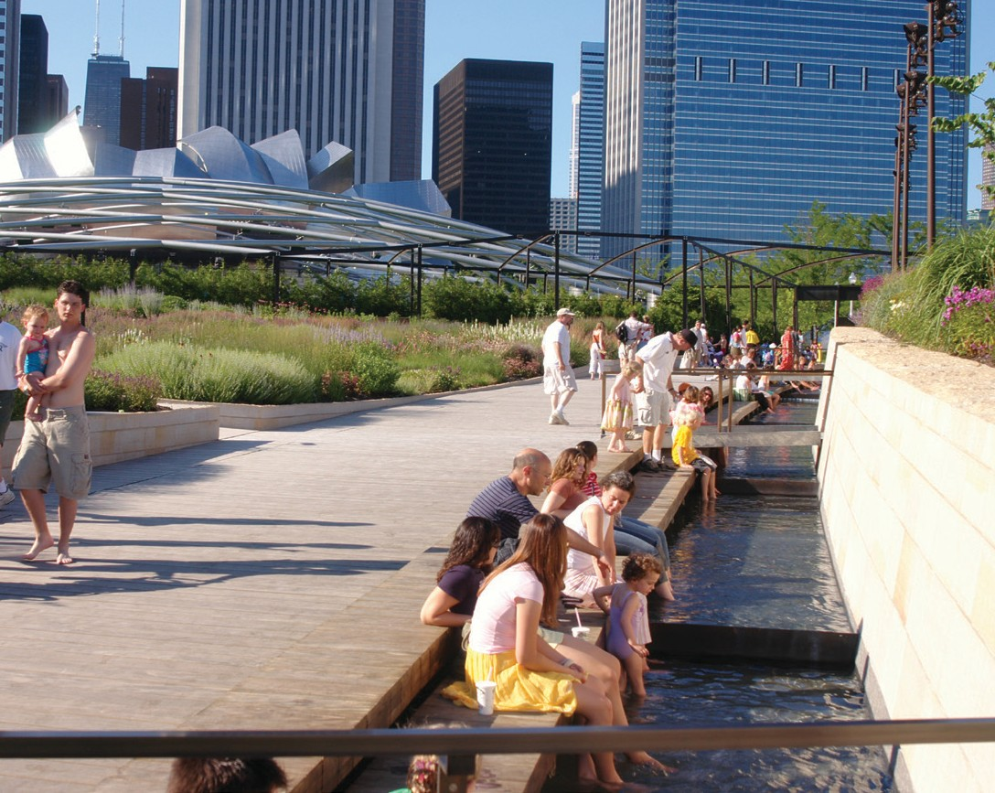
Lurie Garden in Chicago’s Millennium Park is an iconic example of landscape architecture. Firm: GGN. Photo: Piet Oudolf

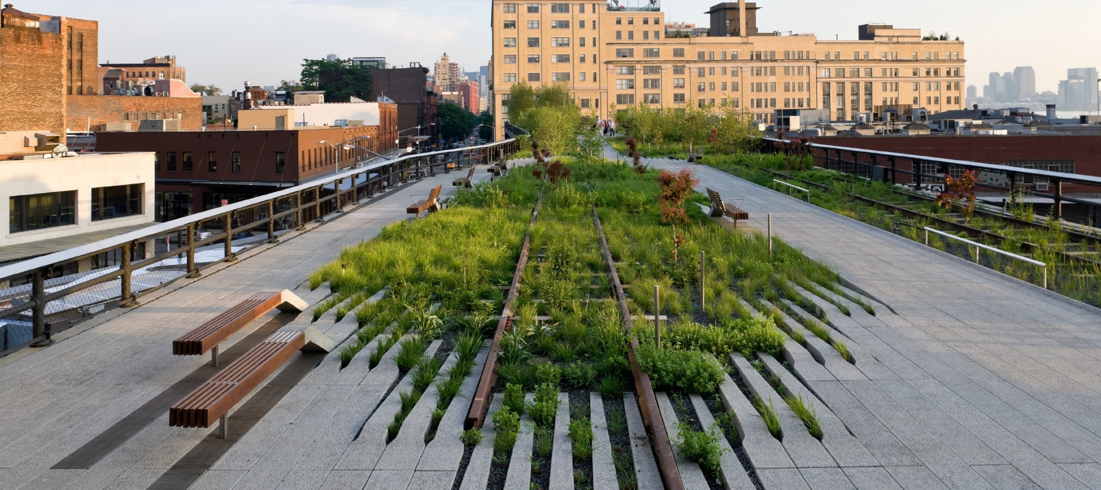

Landscape architects create memorable public spaces. New York’s High Line Park, a former abandoned elevated
railway, now attracts more than two million visitors a year and has spurred over $4 billion in private investment.
Firm: James Corner Field Operations. Photo: Iwan Baan
WHAT IS
LANDSCAPE ARCHITECTURE?


www.asla.org

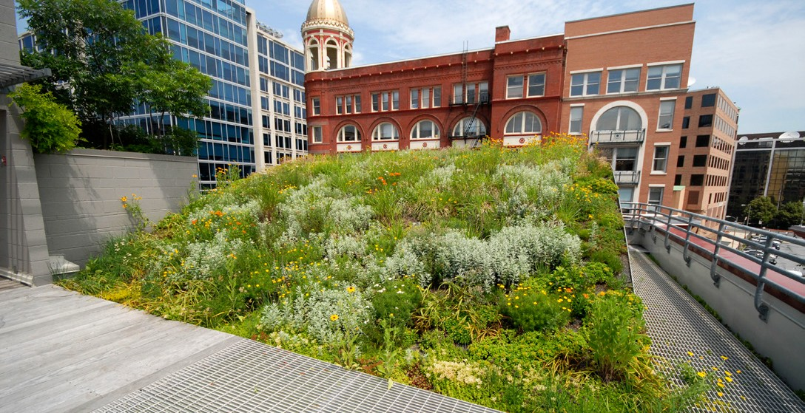
Landscape Architects Manage Water and Stormwater
Landscape architects provide efficient, cost-effective, sustainable infrastructure solutions. Effectively managing stormwater means more than moving runoff to large underground pipes.

Landscape architects use permeable paving, vegetated retention basins, green roofs, bioswales, rain gardens, and other design techniques to reduce runoff, improve water quality, and recharge groundwater supplies.

Landscape Architects Design Transportation Solutions
Landscape architects help communities by designing multiuse transportation corridors that accommodate all users, including pedestrians, bicyclists, motorists, people with disabilities, and people who rely on public transportation. These systems reduce reliance on single-use automotive transport, which in turn reduces traffic, improves air quality, and promotes a more active way of life.

ASLA headquarters’ green roof is one example of how landscape architects help reduce stormwater runoff while also conserving energy and improving air quality. Firm: Michael Van Valkenburgh Associates and Conservation Design Forum.
Photo: ASLA

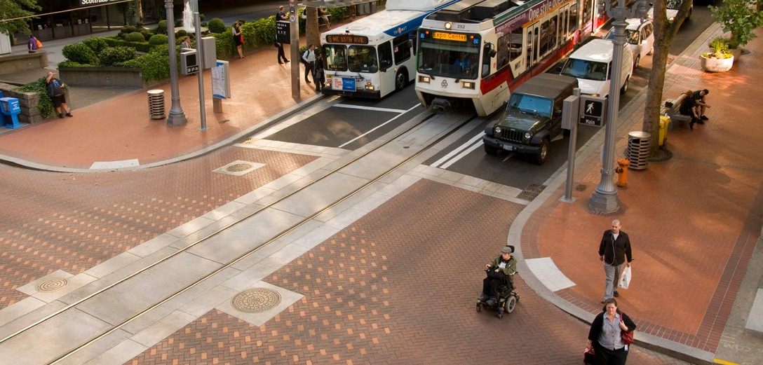
Landscape architects plan and design transportation corridors that consider all users of the roadway—cars, cyclists, pedestrians, mass transit riders, and more.
Firm: ZGF Architects LLP. Photo: Bruce Forster Photography, Inc.


Landscape Architects Support Active Lifestyles

Founded in 1899, the American Society of Landscape Architects (ASLA) is the national professional association representing landscape architects. Beginning with 11 members, ASLA has grown to more than 15,000 members and 49 chapters, representing all 50 states and the District of Columbia.

ASLA promotes the profession of landscape architecture and advances the practice through advocacy, education, communication, and fellowship.

The majority of ASLA members, nearly 80 percent, work in private practice. More than one-third of them are employed by small landscape architecture firms with fewer than 10 employees. Nearly 16 percent of ASLA’s members work in the public sector, including in federal, state, regional, and municipal agencies.

www.asla.org

Landscape architects design communities that support active and healthy lifestyles by linking homes, schools, businesses, parks, and recreation facilities together with walking and bicycle paths and sidewalks that provide safe and easy alternatives to driving.

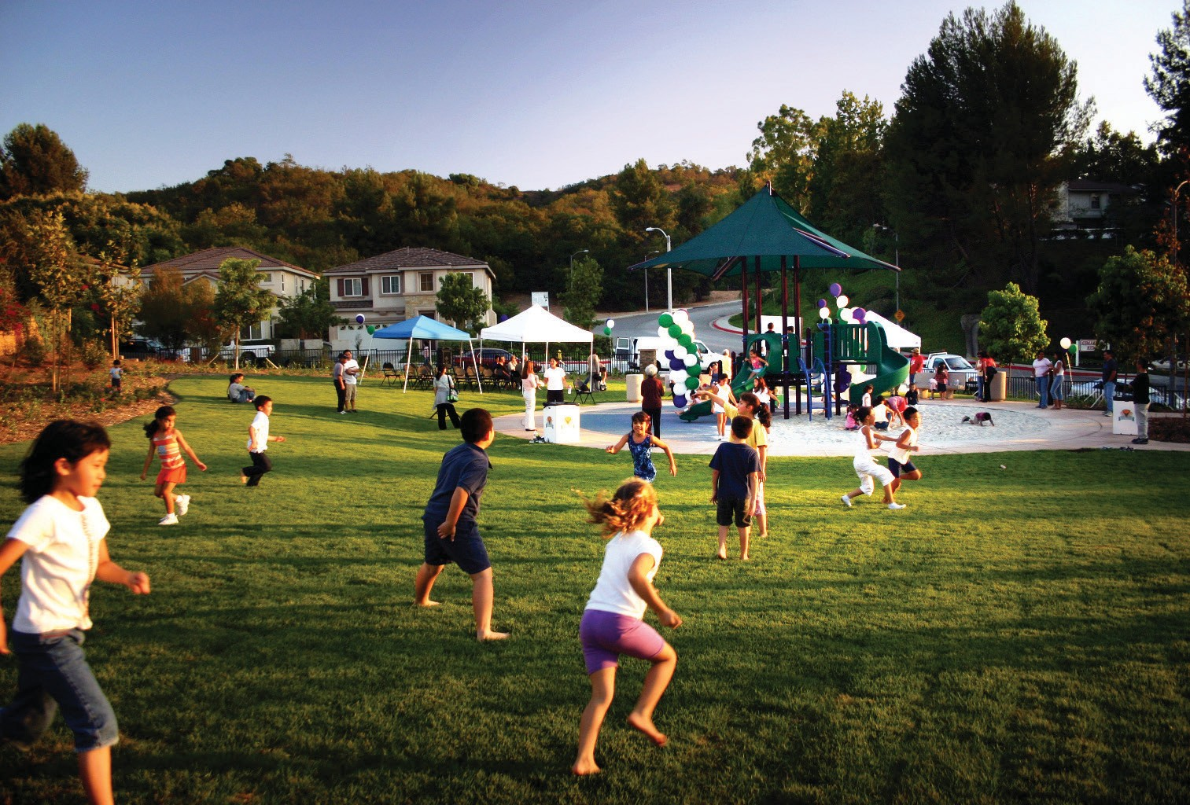

Landscape architects design recreation facilities that keep children and families active and healthy, such as this neighborhood playground in West Covina, California. Firm and Photo: David Volz Design

